A. English Homepage
I recommend/suggest adding a “Global Distribution” or “Where To Buy” section to the English homepage. This visibility would help showcase, support, and promote key distributors worldwide, while also serving as an effective incentive’s tool for attracting prospective distribution partners.
The example below illustrates the proposed layout:
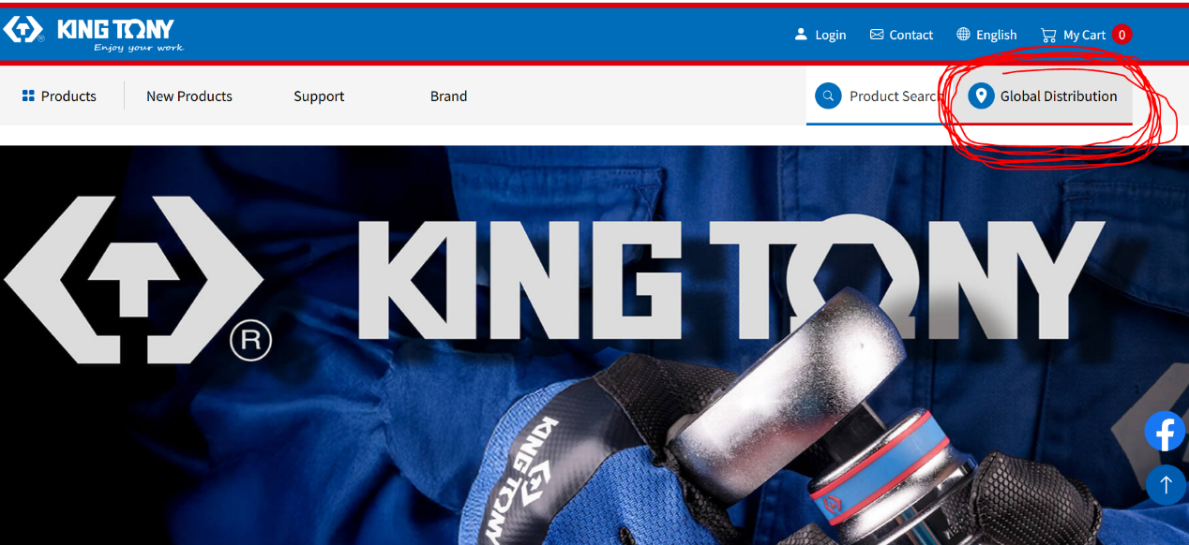
https://www.kingtony.com/dstribution.php?utm_source=KT-Web-Head-en&utm_medium=Distribution

B. English Homepage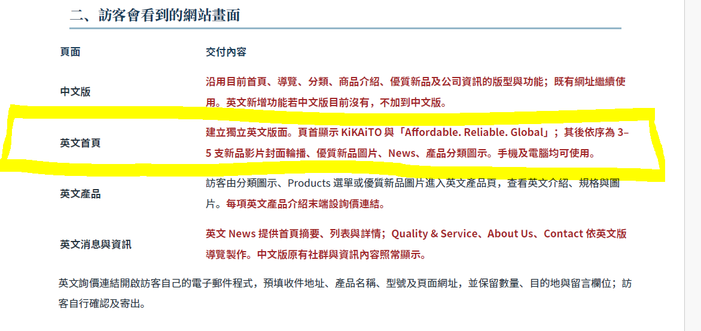
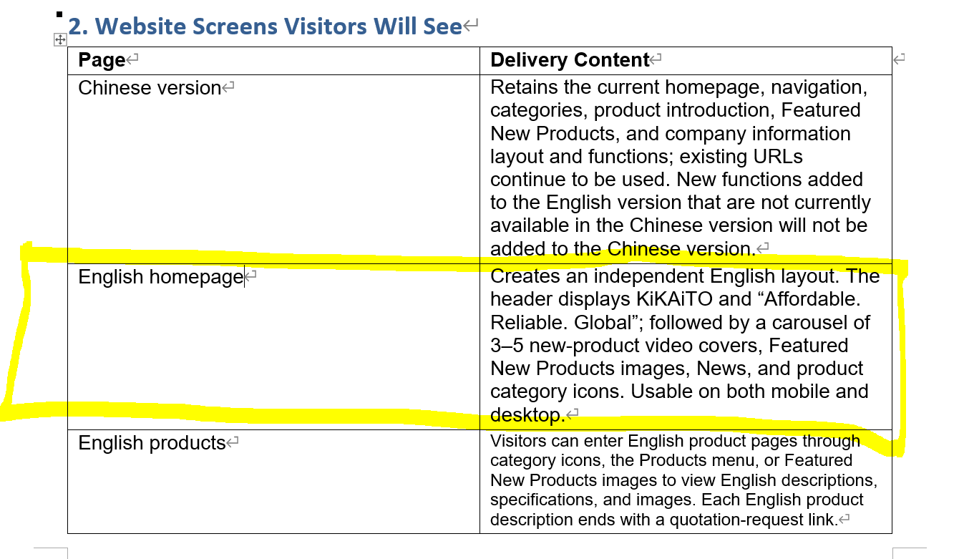

I place particular importance on this section, as it will shape the first impression
visitors and prospective customers have of the company.

Request for clarification:
The scope states: “The header displays KiKAiTO and ‘Affordable. Reliable. Global,’ followed by a carousel of 3–5 new-product video covers.”
Could you please confirm whether these elements will include animation or motion effects?
For reference, the website below illustrates the type of animation I have in mind:
https://caeonline.com/



